**Wanderlust: A Personalized Travel Planning And Tracking App**

1. **Abstract:**

The Personalized Travel Planning and Tracking App is an innovative mobile application designed to transform how users plan, organize, and track their travel experiences. This comprehensive app caters to travelers seeking customized itineraries, real-time tracking, and seamless planning tools that adapt to their preferences and needs.

**Key functionalities include**:

* **Custom Itinerary Builder:** Users can create personalized travel itineraries by inputting destinations, interests, budgets, and travel dates. The app intelligently suggests activities, accommodations, restaurants, and attractions that align with user preferences.
* **Real-time Navigation and Tracking:** The app offers GPS-enabled tracking to help users follow their planned route. It provides notifications about upcoming activities, estimated travel times, and route optimization to enhance the travel experience.
* **Travel Budget Management:** Integrated budget tools help users monitor expenses by category and provide alerts to stay within their budget.
* **Offline Access:** Essential travel information, including maps and itineraries, is available offline, ensuring reliability even in areas with limited connectivity.
* **User-friendly Interface:** The app's design prioritizes ease of use, ensuring a smooth and enjoyable process.

The app is ideal for solo travelers, families, business professionals, and group travelers seeking a streamlined travel experience that prioritizes personalization, efficiency, and comprehensive tracking.

This app simplifies travel planning by centralizing resources and information in one place, allowing users to fully enjoy their travels without the stress of disorganization. Enhanced user satisfaction comes from the app's ability to anticipate and respond to individual travel needs, leading to more fulfilling travel experiences.

1. **Introduction:**

Traveling has become an integral part of modern life, whether for leisure, business, or personal growth. However, organizing and managing travel plans can often be overwhelming and time-consuming due to the abundance of details and choices involved. From creating personalized itineraries and budgeting expenses to tracking schedules and documenting experiences, travelers face the challenge of coordinating multiple aspects to ensure a smooth journey.

To address these challenges, we propose a *Personalized Travel Planning and Tracking App*, a comprehensive solution designed to simplify and enrich the travel experience. This app offers an all-in-one platform that helps users seamlessly plan, track, and enhance their trips according to their unique preferences and requirements. With the support of intelligent planning tools, real-time navigation, collaborative features, and personalized recommendations, travelers can focus more on enjoying their journey rather than managing logistics.

The app caters to diverse user groups, including solo adventurers, families, and professional travelers, providing tailored solutions that adapt to individual needs. Leveraging the latest technology in mobile development and data analytics, this app aims to redefine how people approach travel planning, making it efficient, enjoyable, and memorable.

1. **Data flow diagram:**

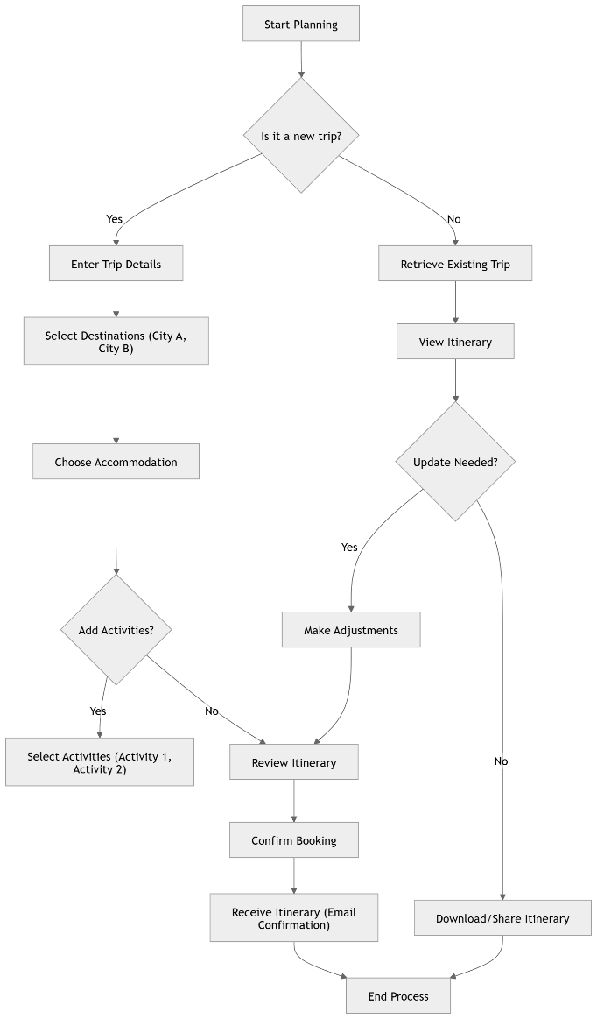

1. **Use case diagram:**

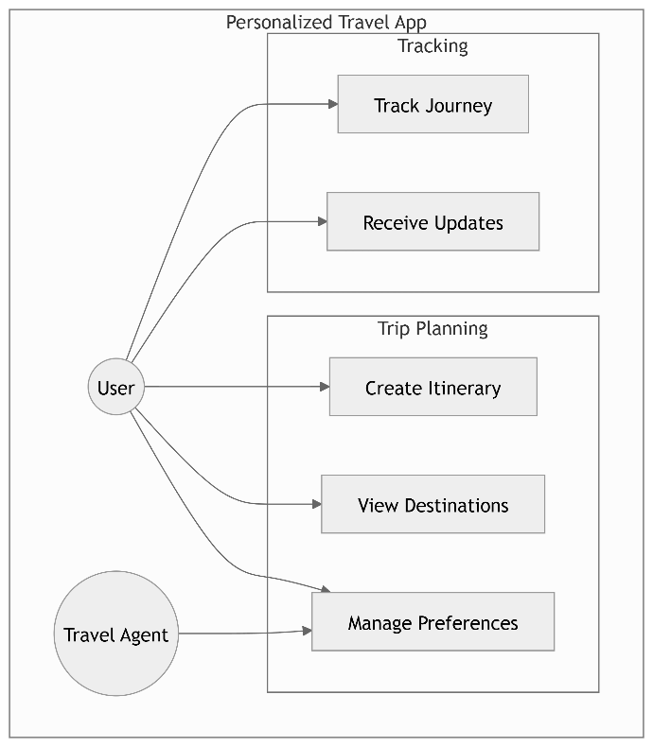

1. **Software Requirement:**
2. Operating System:

• Compatible with Android platforms.

1. Hardware Requirements:

• Android: Devices with at least 2GB of RAM and a quad-core processor.

1. Software Requirements:

• Programming Languages: Java/Kotlin for Android development

• Version Control: Git for managing source code and collaboration among developers.

1. **Sample Program Code :**

package com.example.travelapp  
  
import android.content.Context  
import android.content.Intent  
import android.os.Bundle  
import androidx.activity.ComponentActivity  
import androidx.activity.compose.setContent  
import androidx.compose.foundation.Image  
import androidx.compose.foundation.clickable  
import androidx.compose.foundation.layout.*  
import androidx.compose.foundation.rememberScrollState  
import androidx.compose.foundation.verticalScroll  
import androidx.compose.material.Card  
import androidx.compose.material.Text  
import androidx.compose.runtime.Composable  
import androidx.compose.ui.Alignment  
import androidx.compose.ui.Modifier  
import androidx.compose.ui.draw.scale  
import androidx.compose.ui.graphics.Color  
import androidx.compose.ui.res.painterResource  
import androidx.compose.ui.res.stringResource  
import androidx.compose.ui.text.font.FontFamily  
import androidx.compose.ui.text.font.FontWeight  
import androidx.compose.ui.text.style.TextAlign  
import androidx.compose.ui.unit.dp  
import androidx.compose.ui.unit.sp  
  
class MainActivity : ComponentActivity() {  
 override fun onCreate(savedInstanceState: Bundle?) {  
 super.onCreate(savedInstanceState)  
 *setContent* **{** TravelApp(this)  
 **}** }  
  
  
 @Composable  
 fun TravelApp(context: Context) {  
 Column(  
 modifier = Modifier  
 .*padding*(20.*dp*)  
 .*verticalScroll*(rememberScrollState())  
  
 ) **{** Text(  
 fontSize = 40.*sp*,  
 color = *Color*(android.graphics.Color.rgb(120, 40, 251)),  
 fontFamily = FontFamily.Cursive,  
 text = "Wanderlust Travel"  
 )  
  
 Spacer(modifier = Modifier.*height*(20.*dp*))  
  
 // 01  
 Card(  
 modifier = Modifier  
 .*fillMaxWidth*()  
 .*height*(250.*dp*)  
 .*clickable* **{** context.startActivity(  
 Intent(context, BaliActivity::class.*java*)  
  
 )  
 **}**,  
 elevation = 8.*dp* )  
 **{** Column(  
 horizontalAlignment = Alignment.CenterHorizontally  
 ) **{** Image(  
 painterResource(id = R.drawable.*bali*), contentDescription = "",  
 modifier = Modifier  
 .*height*(150.*dp*)  
 .*scale*(scaleX = 1.2F, scaleY = 1F)  
 )  
  
 Text(  
 text = stringResource(id = R.string.*place_1*),  
 fontSize = 18.*sp* )  
  
  
 Text(  
 text = stringResource(id = R.string.*description*),  
 fontWeight = FontWeight.Light,  
 fontSize = 16.*sp*,  
 textAlign = TextAlign.Center,  
 )  
  
 Text(  
 text = stringResource(id = R.string.*plan*), color = Color.Gray,  
 fontSize = 16.*sp* )  
 **}  
 }** Spacer(modifier = Modifier.*height*(20.*dp*))  
  
  
 //02  
 Card(  
 modifier = Modifier  
 .*fillMaxWidth*()  
 .*height*(250.*dp*)  
 .*clickable* **{** context.startActivity(  
 Intent(context, ParisActivity::class.*java*)  
  
 )  
 **}**,  
 elevation = 8.*dp* )  
 **{** Column(  
 horizontalAlignment = Alignment.CenterHorizontally  
 ) **{** Image(  
 painterResource(id = R.drawable.*paris*), contentDescription = "",  
 modifier = Modifier  
 .*height*(150.*dp*)  
 .*scale*(scaleX = 1.2F, scaleY = 1F)  
 )  
  
 Text(  
 text = stringResource(id = R.string.*place_2*),  
 fontSize = 18.*sp* )  
  
  
 Text(  
 text = stringResource(id = R.string.*description*),  
 fontWeight = FontWeight.Light,  
 fontSize = 16.*sp*,  
 textAlign = TextAlign.Center,  
 )  
  
 Text(  
 text = stringResource(id = R.string.*plan*), color = Color.Gray,  
 fontSize = 16.*sp* )  
 **}  
 }** Spacer(modifier = Modifier.*height*(20.*dp*))  
  
 //03  
 Card(  
 modifier = Modifier  
 .*fillMaxWidth*()  
 .*height*(250.*dp*)  
 .*clickable* **{** context.startActivity(  
 Intent(context, SingaporeActivity::class.*java*)  
  
 )  
 **}**,  
 elevation = 8.*dp* )  
 **{** Column(  
 horizontalAlignment = Alignment.CenterHorizontally  
 ) **{** Image(  
 painterResource(id = R.drawable.*singapore*), contentDescription = "",  
 modifier = Modifier  
 .*height*(150.*dp*)  
 .*scale*(scaleX = 1.2F, scaleY = 1F)  
 )  
  
 Text(  
 text = stringResource(id = R.string.*place_3*),  
 fontSize = 18.*sp* )  
  
  
 Text(  
 text = stringResource(id = R.string.*description*),  
 fontWeight = FontWeight.Light,  
 fontSize = 16.*sp*,  
 textAlign = TextAlign.Center,  
 )  
  
 Text(  
 text = stringResource(id = R.string.*plan*), color = Color.Gray,  
 fontSize = 16.*sp* )  
 **}  
 }** Spacer(modifier = Modifier.*height*(20.*dp*))  
 **}** }  
}

1. **Output**

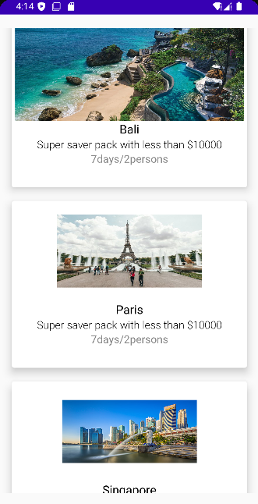

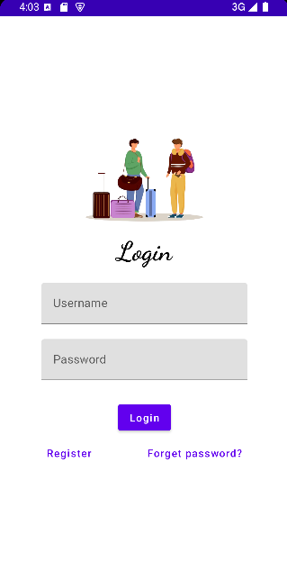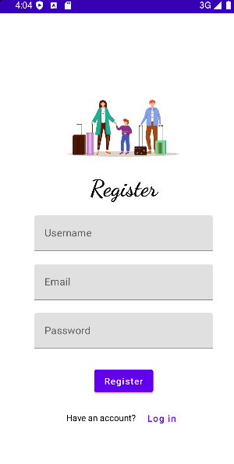

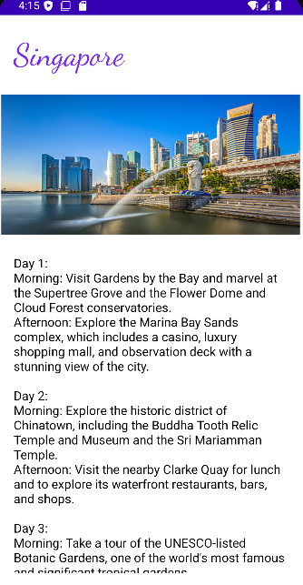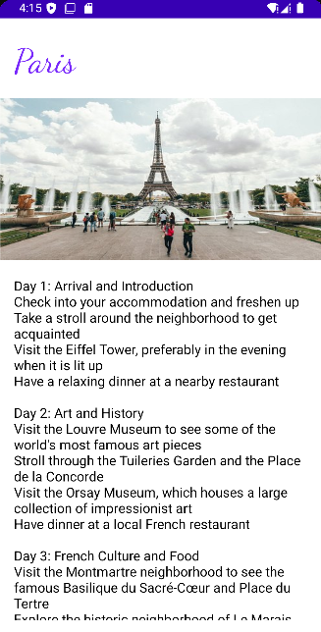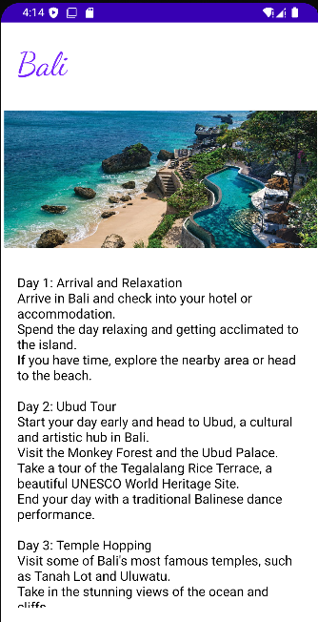

1. **Conclusion:**

The **Personalized Travel Planning and Tracking App** represents a transformative approach to modern travel management, aiming to simplify and enhance the user experience by centralizing travel planning, real-time tracking, and itinerary customization in one cohesive platform. By integrating intelligent planning tools, seamless budget management, real-time navigation, and collaborative features, the app empowers travelers to plan efficiently and enjoy their journeys with minimal stress.

1. **Future Enhancement:**

To continually improve and adapt to user needs, several enhancements are planned for the future development of Snack Squad:

* AI-Powered Personalization: Implement machine learning algorithms to provide more personalized and dynamic travel suggestions based on user behavior, past trips, and real-time travel trends.
* Augmented Reality integration: Offer an interactive wayfinding feature that overlays directions onto real-world views through the phone’s camera.
* Multilingual Support: Include real-time text and voice translation features to assist travelers in foreign countries.
* Enhanced Social Fearures: Allow users to share travel tips, reviews, and experiences with a community of travelers.
* Integration with Smart Devices: Sync with smartwatches and fitness trackers to provide step-by-step directions, travel reminders, and health tracking during trips.
* Dynamic Weather Alerts : Provide integrated weather forecasting and alerts that inform users of weather conditions at their destinations and suggest itinerary adjustments if needed.
* Sustainability Features: Highlight and recommend sustainable travel practices, such as eco-friendly hotels, carpooling services, and public transport routes.
* Emergency Assistance: Introduce an emergency button that connects travelers to local authorities or emergency contacts.
* Global Expansion: Scaling the app to support multiple languages and currencies, enabling Snack Squad to serve users worldwide.